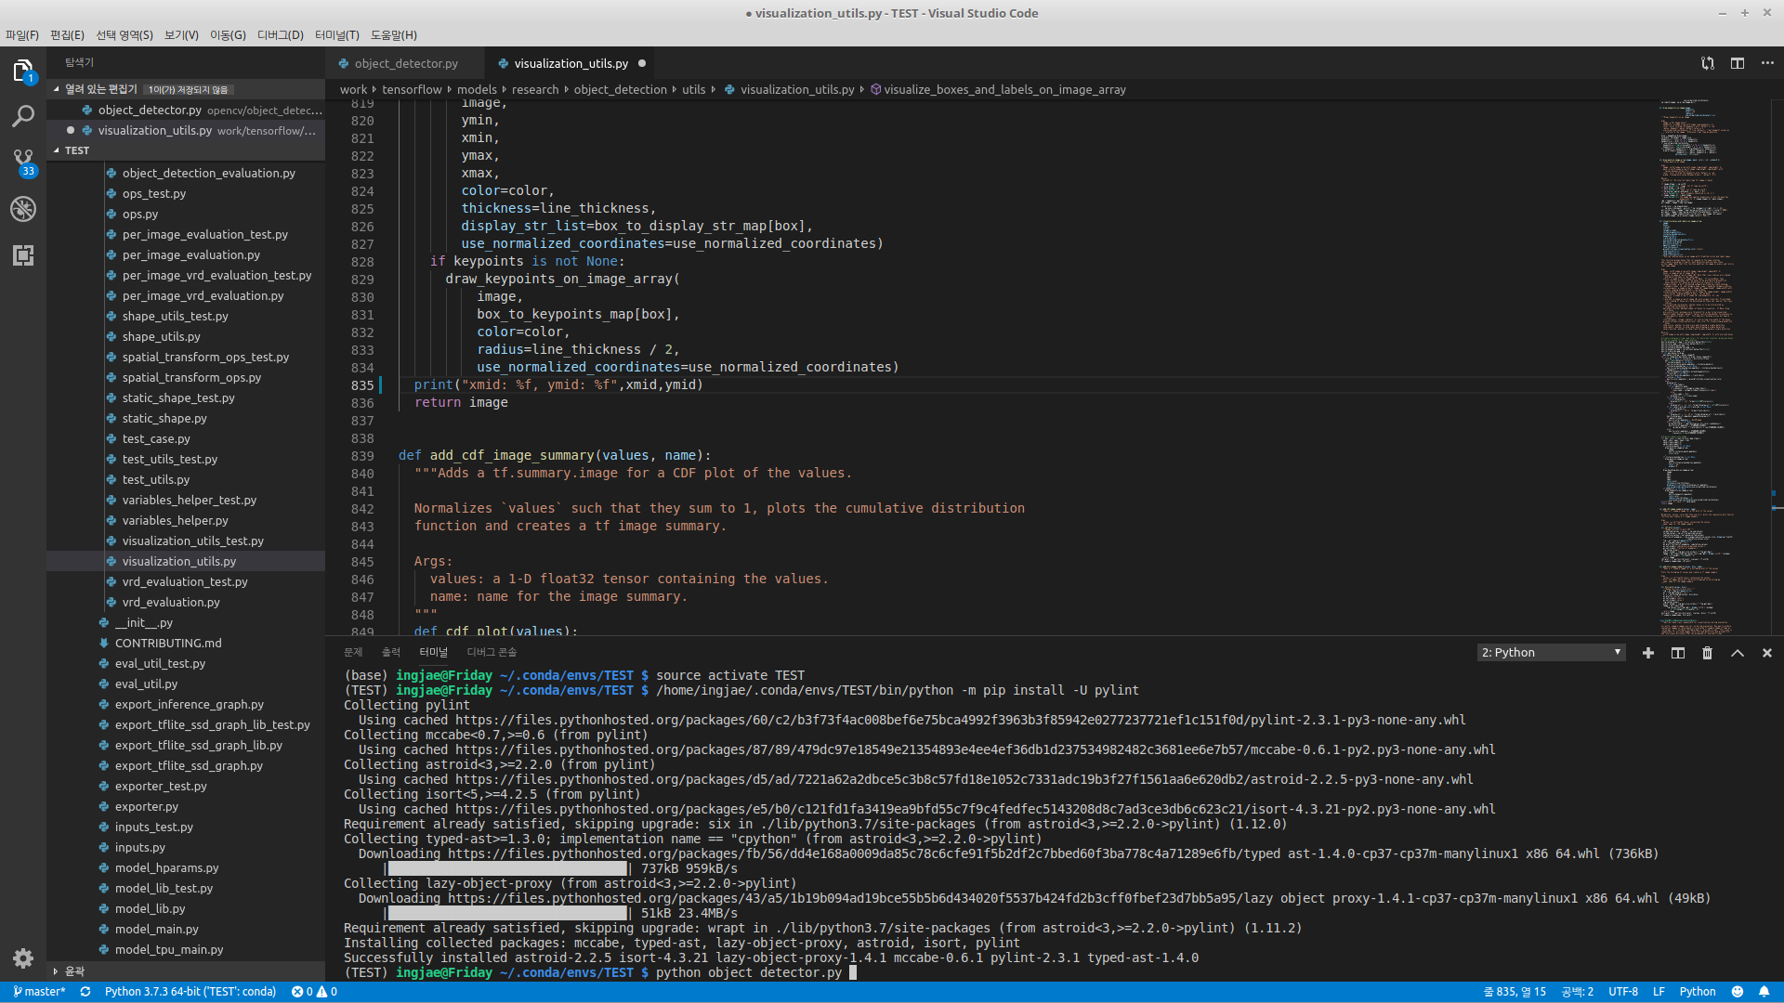

(TEST) ingjae@Friday ~/.conda/envs/TEST/opencv/object_detection_tensorflow $ python object_detector.py
